**TASK 18 OUTPUT:**

To Automated Facebook Sign Up Process using Selenium script.

**STEPS PERFORMED ARE:**

1.Opening the chrome browser

2.Navigates to <https://www.facebook.com/>

3.Maximised the browser window.

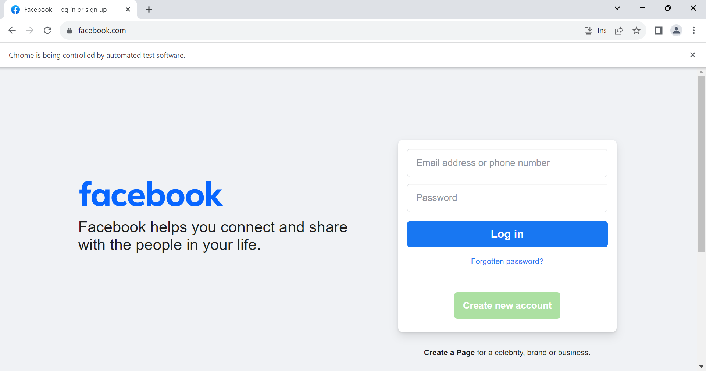

4. getTitle method was used to verify that the website has been redirected to the Facebook homepage.

5.Details were filled in the form using different locators.

6.Action class and Select class were used to select the options from the dropdown box and perform different actions.

9. Gender was selected as "Female" using the radio button.

10. "Sign Up" button was clicked.

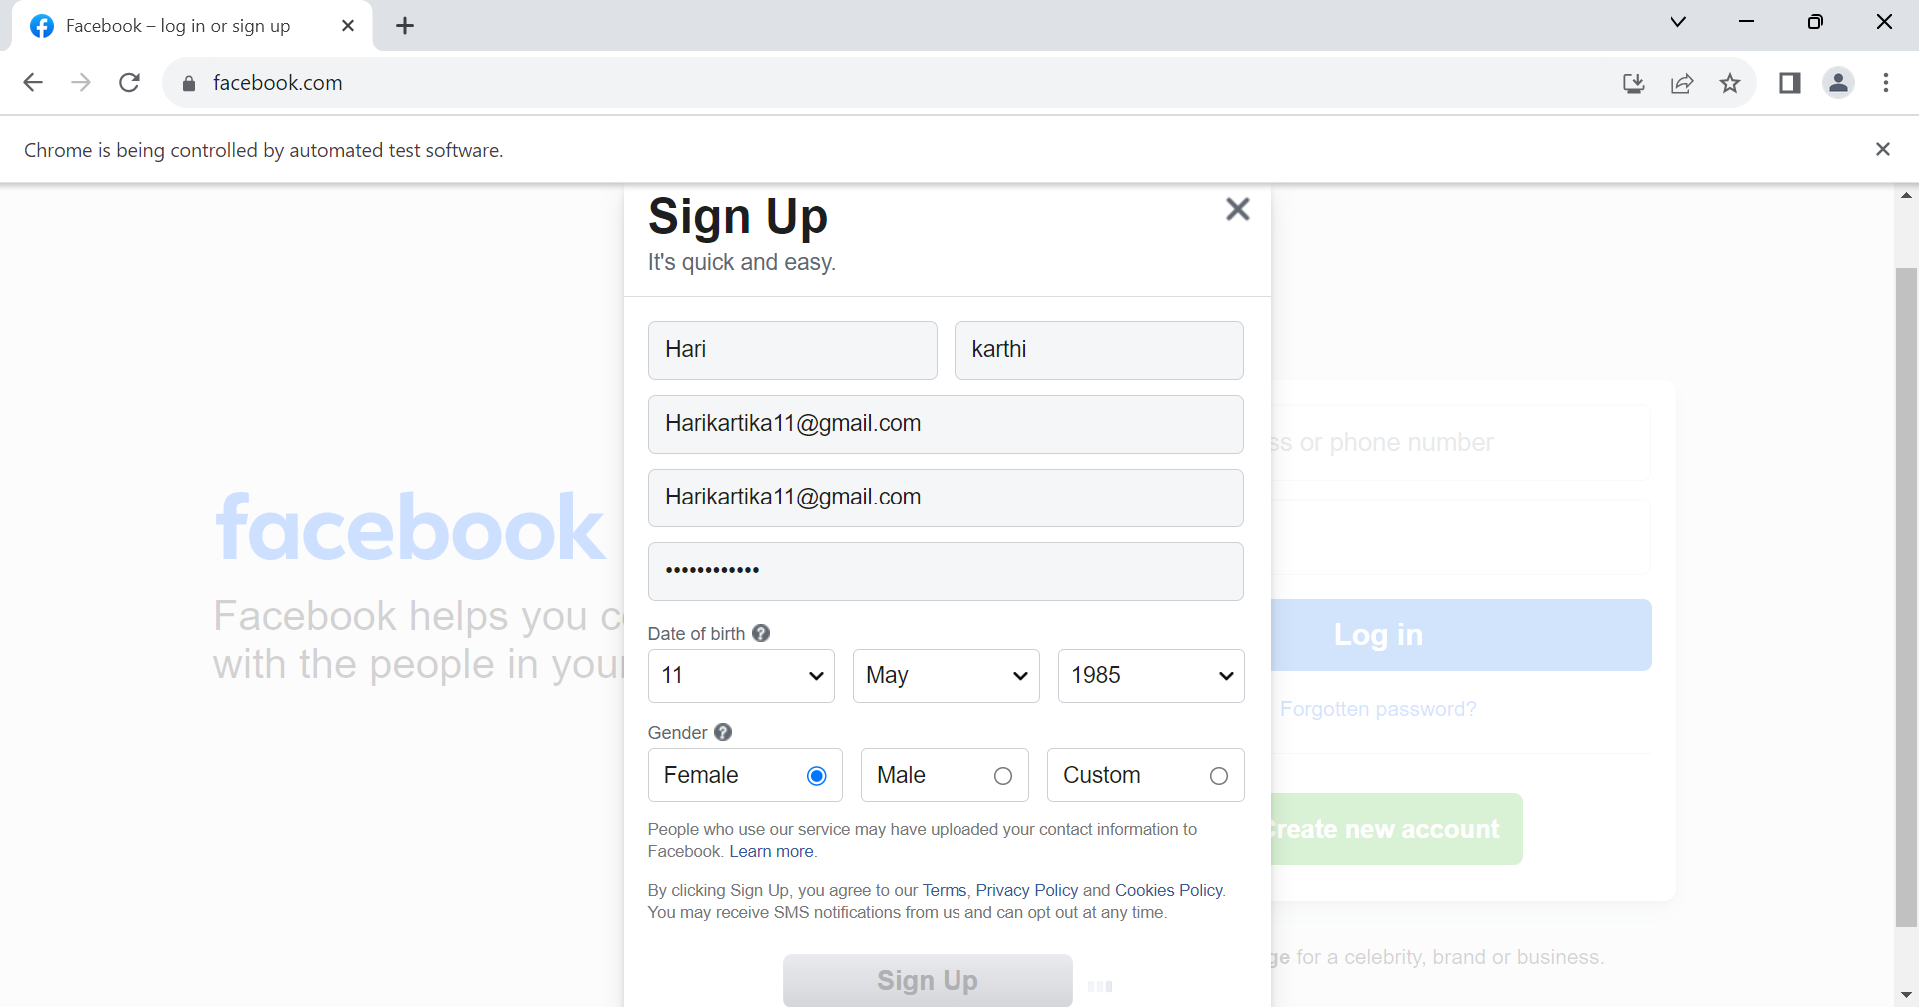

11.Message was popped as show below .

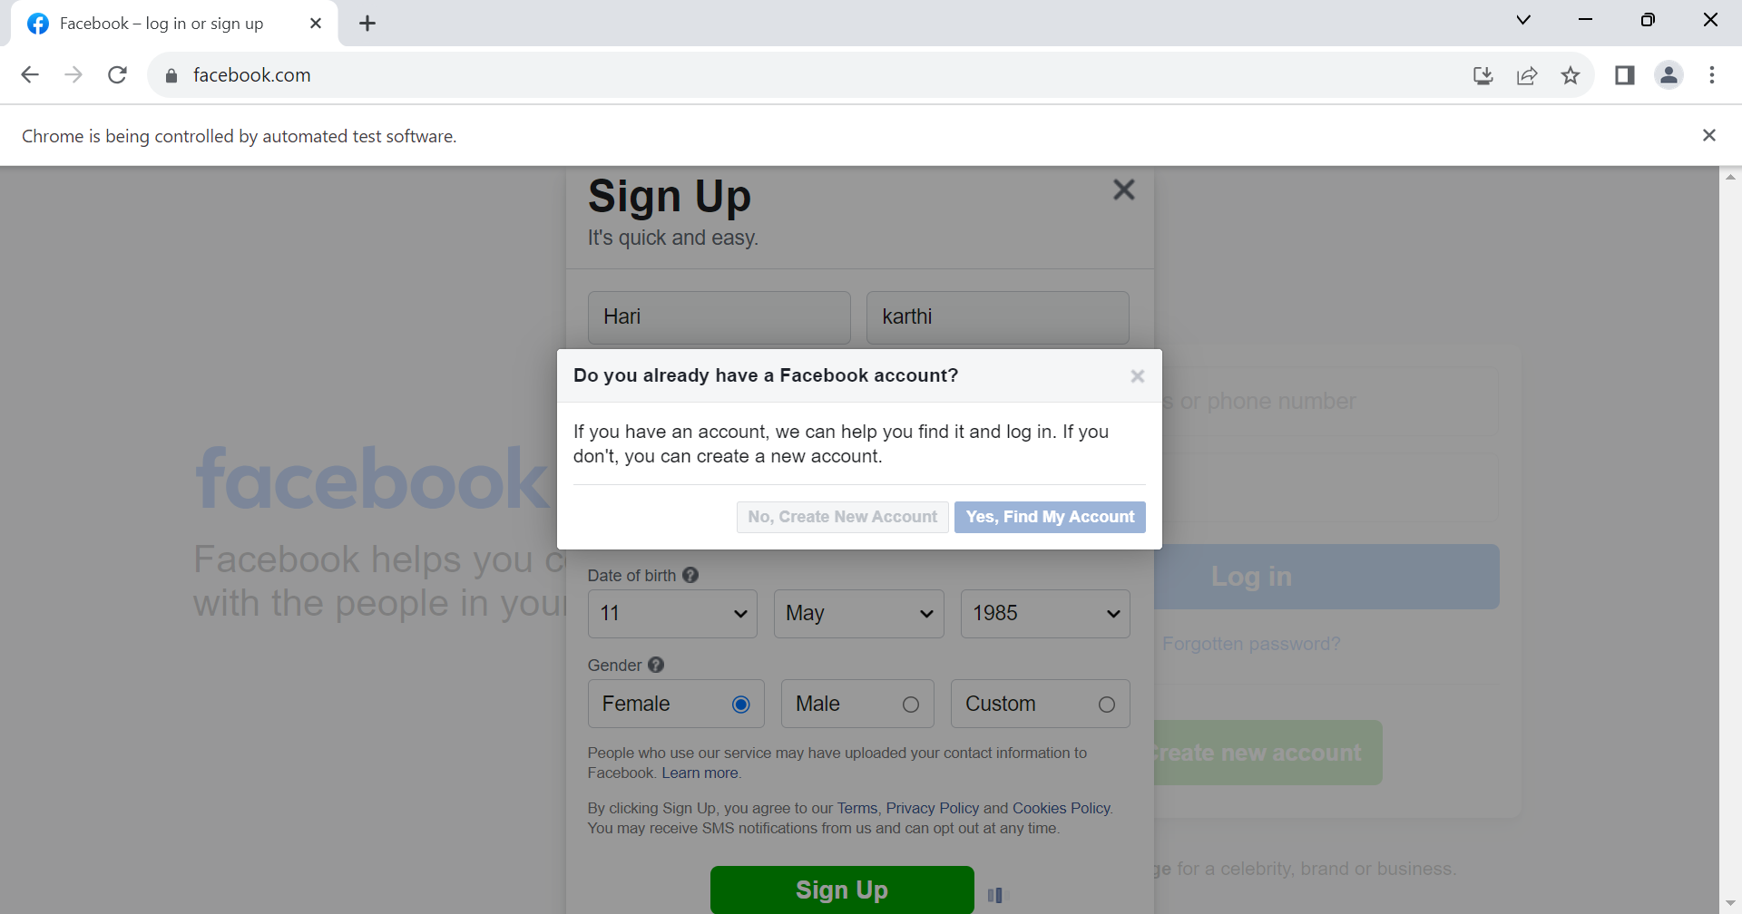

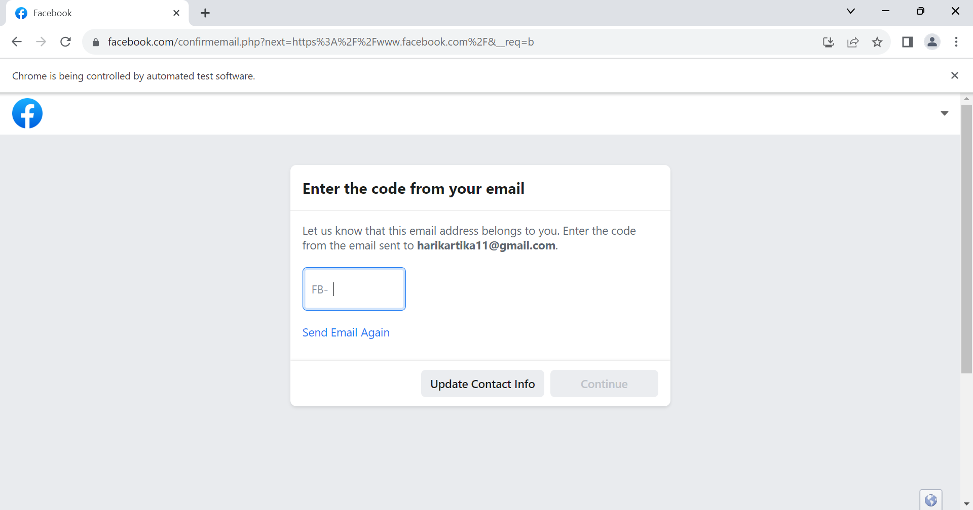

12. If else condition was used to check that the user is successfully registered on Facebook or not.

13.Here the “User is no successfully registered” so didn’t direct to the facebook page.

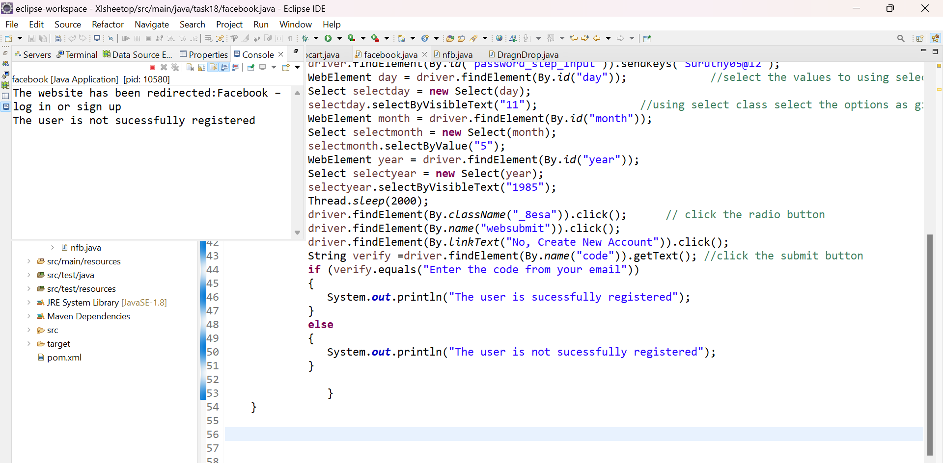

**2. Automated Drag and Drop Operation using Selenium Java.**

**Steps performed:**

1.Opening the chrome browser

2.Navigates to <https://jqueryui.com/droppable/>

3.Maximised the browser window.

4. Frame is used for dividing the web page into various frames .Here the element were inside the frame so frame method was used.

5.Source and target element were inspected.

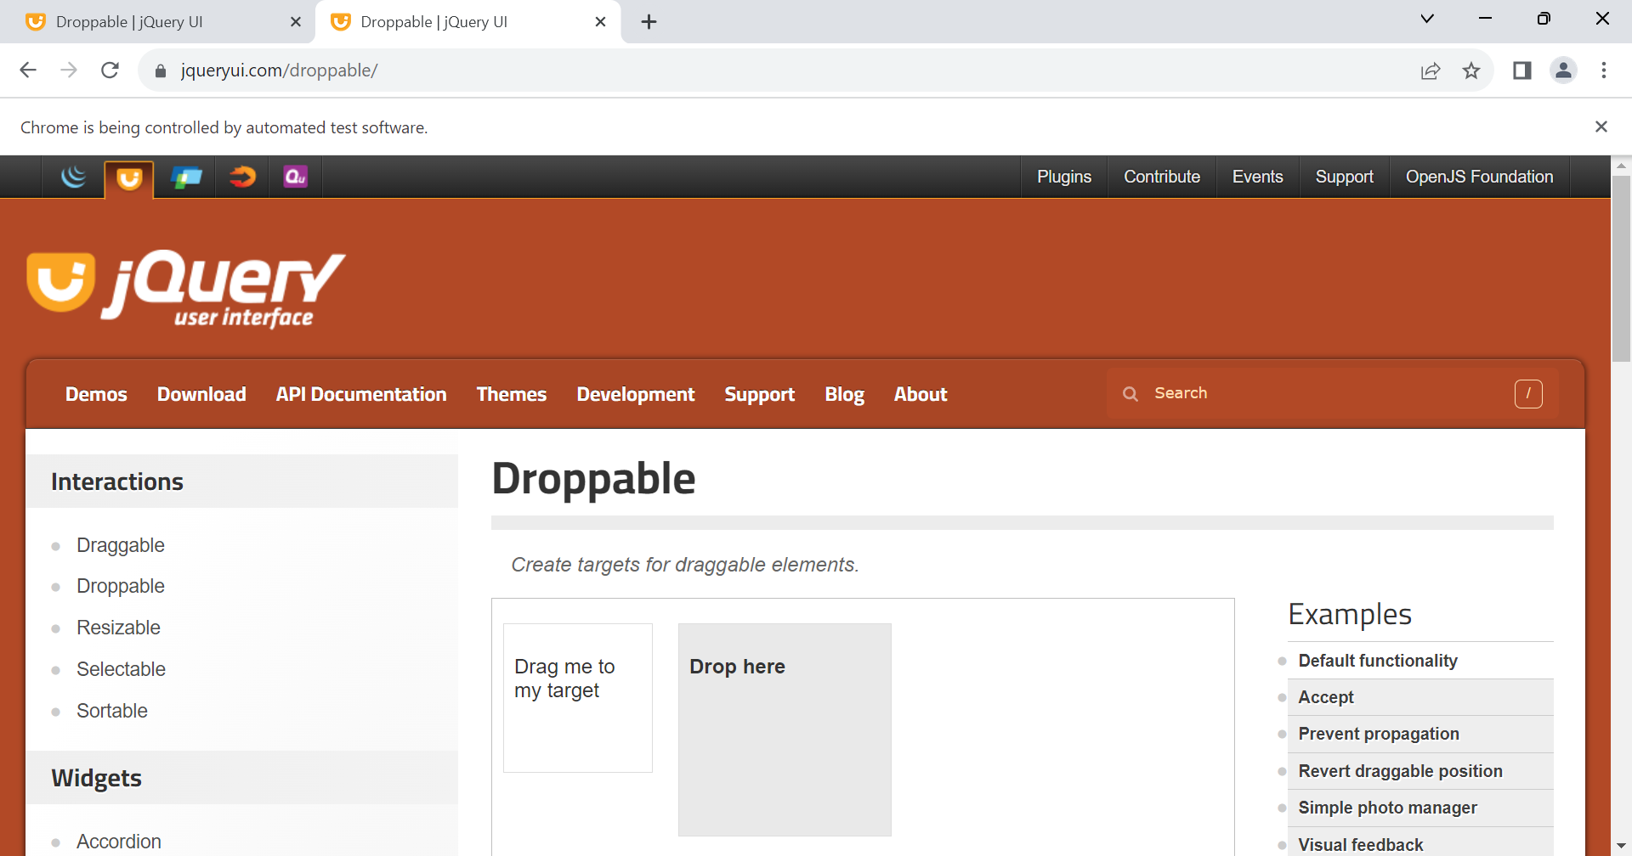

6.Drag and drop mouse operation was performed using drag and drop method.

7. Color property of target element was changed using css class.

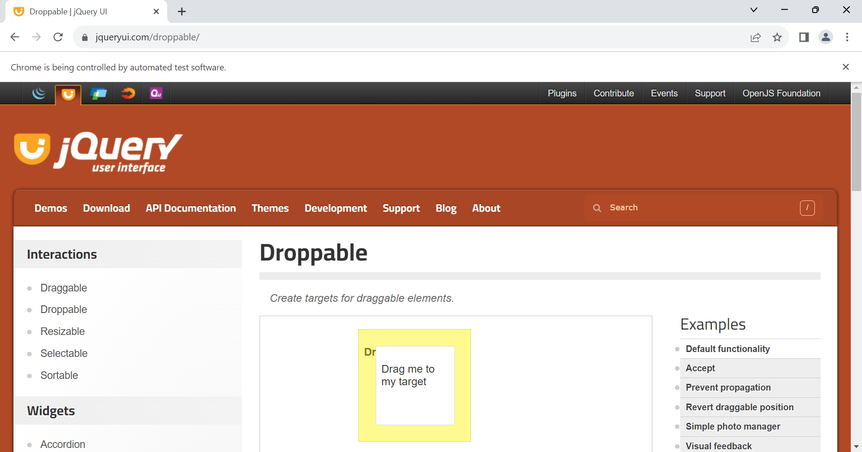

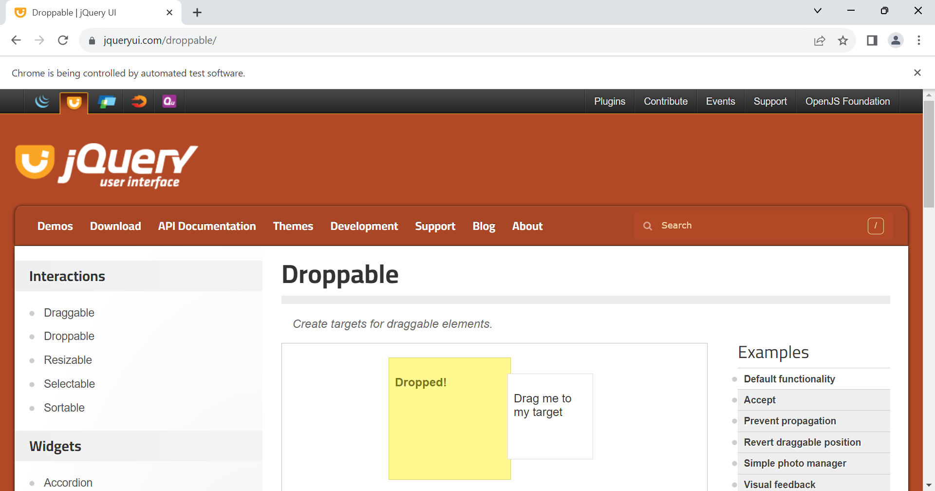

8. Text of the target element has changed to "Dropped!"

